Problem Statement - Assignment 2
Name: Bezawada Hemanth Chowdary
- Where would you rate yourself on (LLM, Deep Learning, AI, ML). A, B, C [A = can code independently; B = can code under supervision; C = have little or no understanding]
I would rate myself as follows:
Domain | Rating
Large Language Models | C
Deep Learning | B
Artificial Intelligence | B
Machine Learning | B

My justification:
Large Language Models: I have used a lot of LLMs in the past couple of years and I know how LLMs work, their architecture. But I didn’t get the opportunity to build a LLM because of the hardware. Because of this limitation of no practical exposure, I would rate myself a C but I would very much like to build my own LLM and to use my theoretical knowledge into building something useful.
Deep Learning:I have a theoretical understanding and also familiar with how the role works especially in the area of NLP. Most of my knowledge comes from the projects I’ve built around it. Few of them are, Automated Essay Scoring System which was a research project and also a Neural Machine Translation system. I have worked with multiple AI ML tools and frameworks. But I have to agree that my practical experience on designing and optimizing those neural network models is limited. For this reason, I would rate myself as a B. With my understanding and guidance/supervision from an experienced professional, I think I will do great.
Artificial Intelligence: My knowledge in AI comes after using AI applications and studying a lot of academic papers and projects. I am confident that I understand how AI techniques can be used to solve complex problems and how the AI application architectures work under the hood. So being honest I would rate myself a B in this category. I want to improve my practical skills by building AI applications.
Machine Learning: This is where most of my projects come from. I have worked on multiple projects including my Insurance cold calling project which won me a best project award. I have worked with multiple algorithms including Random Forest, KNNs, Decision Trees, SVM, and regression algorithms. I understand how these algorithms work, which are best to use and where. But optimizing an algorithm like an experienced professional and building a complete machine learning workflow cleanly is something where I need to work most. I am slightly moving towards A but to be fair I want to go with B.
- What are the key architectural components to create a chatbot based on LLM? Please explain the approach on a high-level
High level architecture 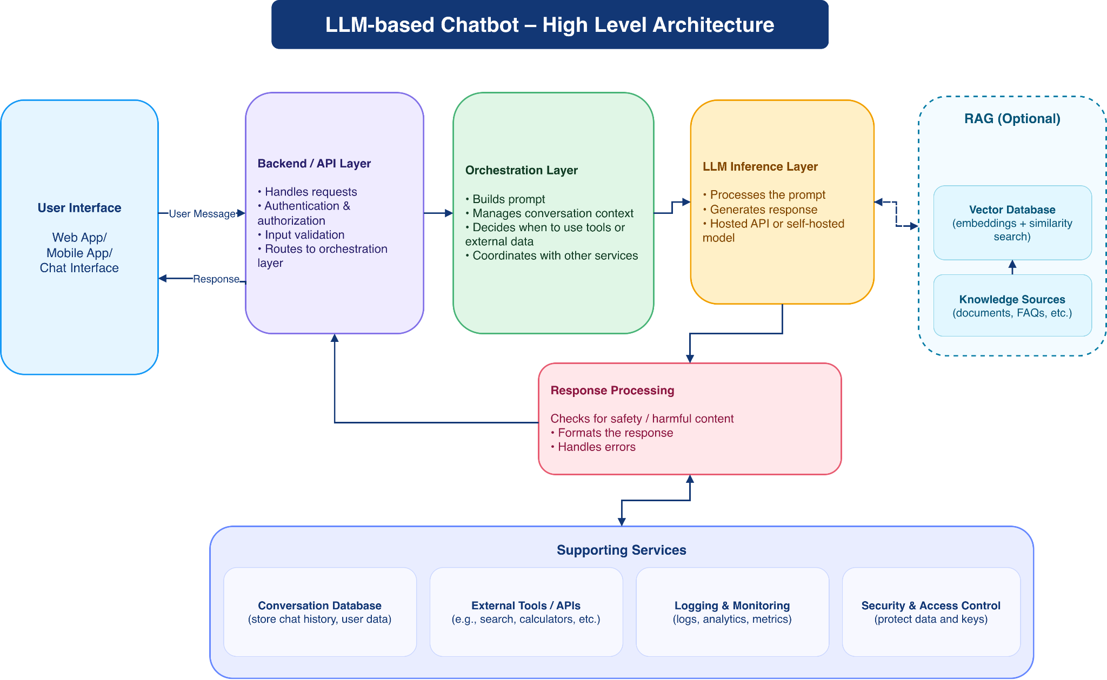
General overview of a chatbot architecture
*Designed using draw.io
Components:
- User interface: Interface for users to interact with the chatbot
- Backend/API layer: Connects the interface and the backend layer that handles user requests, auth
- Orchestration layer: builds prompts, manages conversation history and responsible for deciding whether tools or external knowledge is needed or not
- LLM: This where the context is processed and the response is generated
- Response Processing: Verify output safety and formats the response for the user.
- Supporting services: External connections, and stores conversation history when needed
General message flow:
User sends a message
↓
Backend validates the message request and send it to the orchestration layer
↓
System prepares the prompt and the relevant conversation context
↓
If necessary, it will get information from external resources or tools
↓
Then the LLM generates a response based on all the information gathered
↓
The system validates the response and sends it back to the user
- Please explain vector databases. If you were to select a vector database for a hypothetical problem (you may define the problem) which one will you choose, and why?
Vector database:
Database that is used to store, manage, and index high dimensional, numerical, unstructured data.
Example Problem:
For example, students have a lot of notes, pdfs, documents, and it is difficult and takes time to go through them and learn specific topics. A chatbot that can help by answering the questions from students based on their notes and documents.
Most common databases are pgvector(Postgresql), chromaDB and pinecone.
ChromaDB is mostly known as a beginner friendly database as it runs directly in python without any setup. Vector databases are only necessary when dealing with huge data as it becomes hard to keep context.
We should keep three important things in mind while designing a LLM with a vector database. What is the problem the students are facing?, how can the chatbot use vector database?, and workflow for generating a useful answer?

How it works:
Notes and PDFs
↓
Splits the documents into smaller chunks
↓
Converts these smaller chunks into vectors
↓
Vector databases store these vectors
↓
Finds the relevant information for the student’s question
↓
LLM generates the answer and sends it to the student

